Banner

Web Time Entry

Approver’s Handbook

Welcome to Banner Web Time Entry

The Web Time Entry system allows employees to individually log onto the mybanner.kenyon.edu secure website and enter the hours worked online from any computer anywhere (on campus or off campus). The employee time is approved online by the designated approver or their proxy and then it is sent electronically to payroll for processing.

This handbook outlines the process used by approvers and proxies to approve the hours their employees have worked each pay period.

If you have any questions, please call or email:

Cathy Riel
Payroll Manager
740-427-5144
riel@kenyon.edu

Thank you,

Cathy

- Login to Web Time Entry through Employee Self Service

You will log into mybanner.kenyon.edu if you are on campus and remote.kenyon.edu if you are off campus in order to access the Self-Service link. You can access this from any computer on or off campus.

On Campus: Enter your employee ID number and password.
Off Campus: Enter your network User Name and password then your employee ID number and password.

If you have trouble logging into the Employee Self Service call the Help Desk at 740-427-5700.

- Access Time Sheets for Approval

Once you are logged in click on Employee menu then Time Sheet menu. This will take you to the Time Reporting Section Screen. Make sure the Approve or Acknowledge Time button is populated. If you are acting as a proxy for someone (see section 8 for how to assign a proxy), click the box next to the “Act as Proxy” box and select the name of the person for whom you are acting as a proxy. If you are acting as the original approver leave the “Act as Proxy” box set to self.

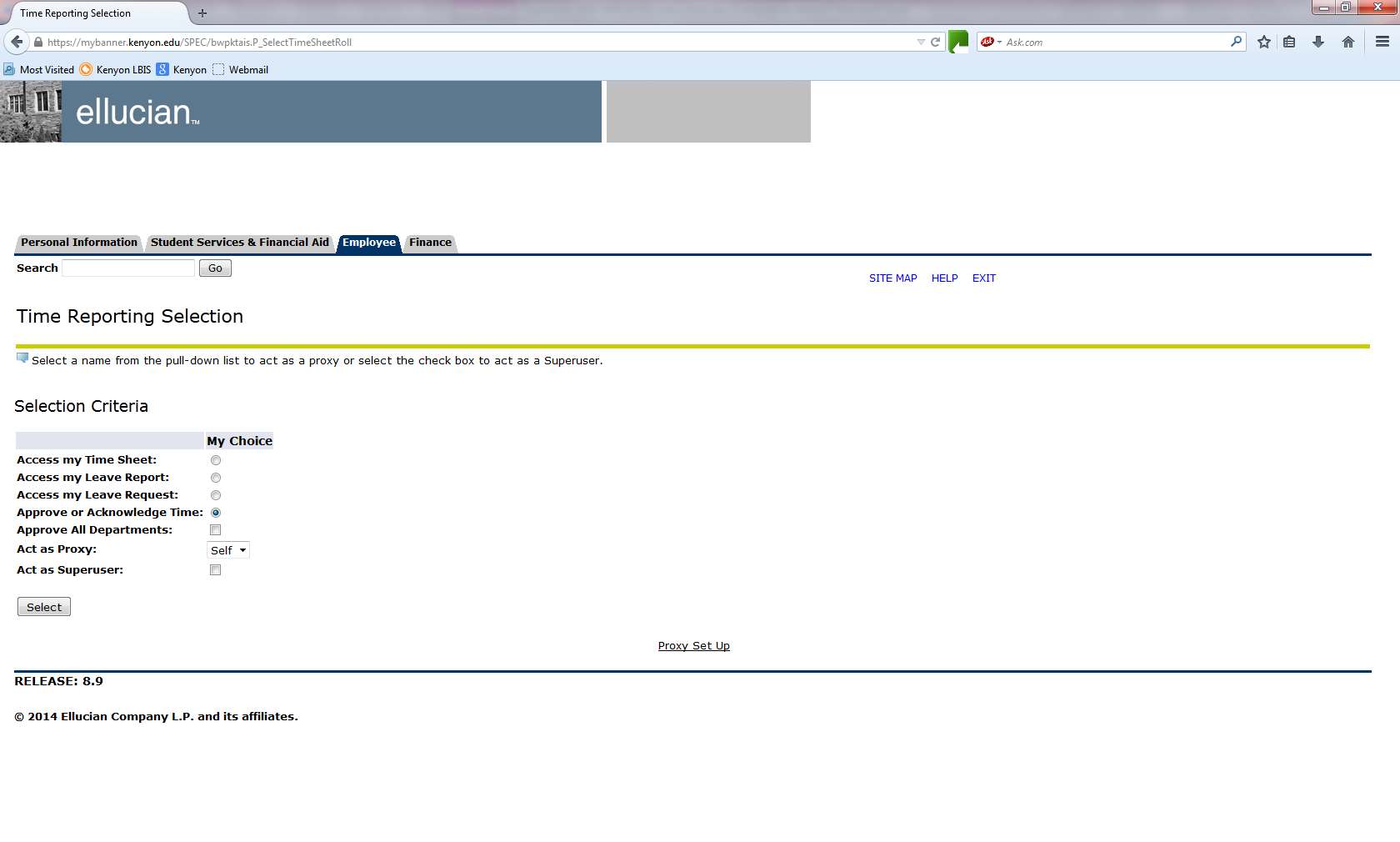

Your screen will automatically show up with a dot in the Approve or Acknowledge Time spot. If you need to change the sort order of the employees, click in the My Choice area to change the default. Click on the Select button. You will not be acting as a Superuser.

- Choose the Department and Pay Period

If you have more than one department to approve, choose the department by clicking on the radio button under My Choice. Important: Choose the correct time period you wish to approve. (Past pay periods will remain visible for review although it is not possible to make any changes to them).

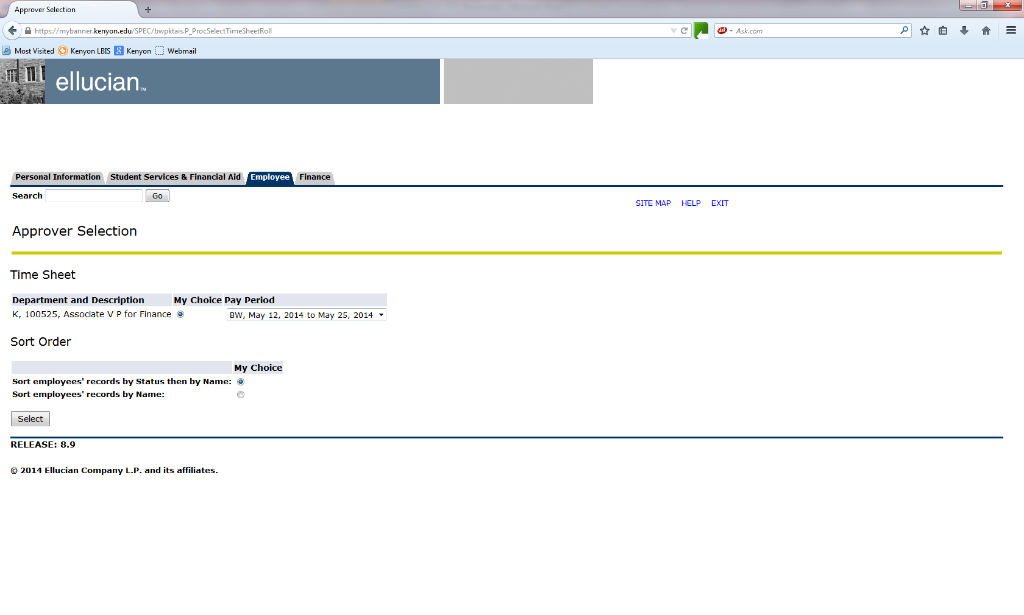

Select the sort order in which you wish the records to be displayed. Click the Select button.

- Summary page

The Summary page shows the status of employee timesheets in the selected department. Important: You can only approve Pending records. Employees who have not submitted their time sheet for approval will either appear as In Progress (time sheet has been started) or Not Started (time sheet has not been initiated).

To view the detail of hours worked by day and type for each employee, click on their name. This will take you to the Employee Detailed Information page. You may approve hours from the Summary page or Employee Detailed Information page. You are certifying, by your approval, that the employee actually worked the hours indicated.
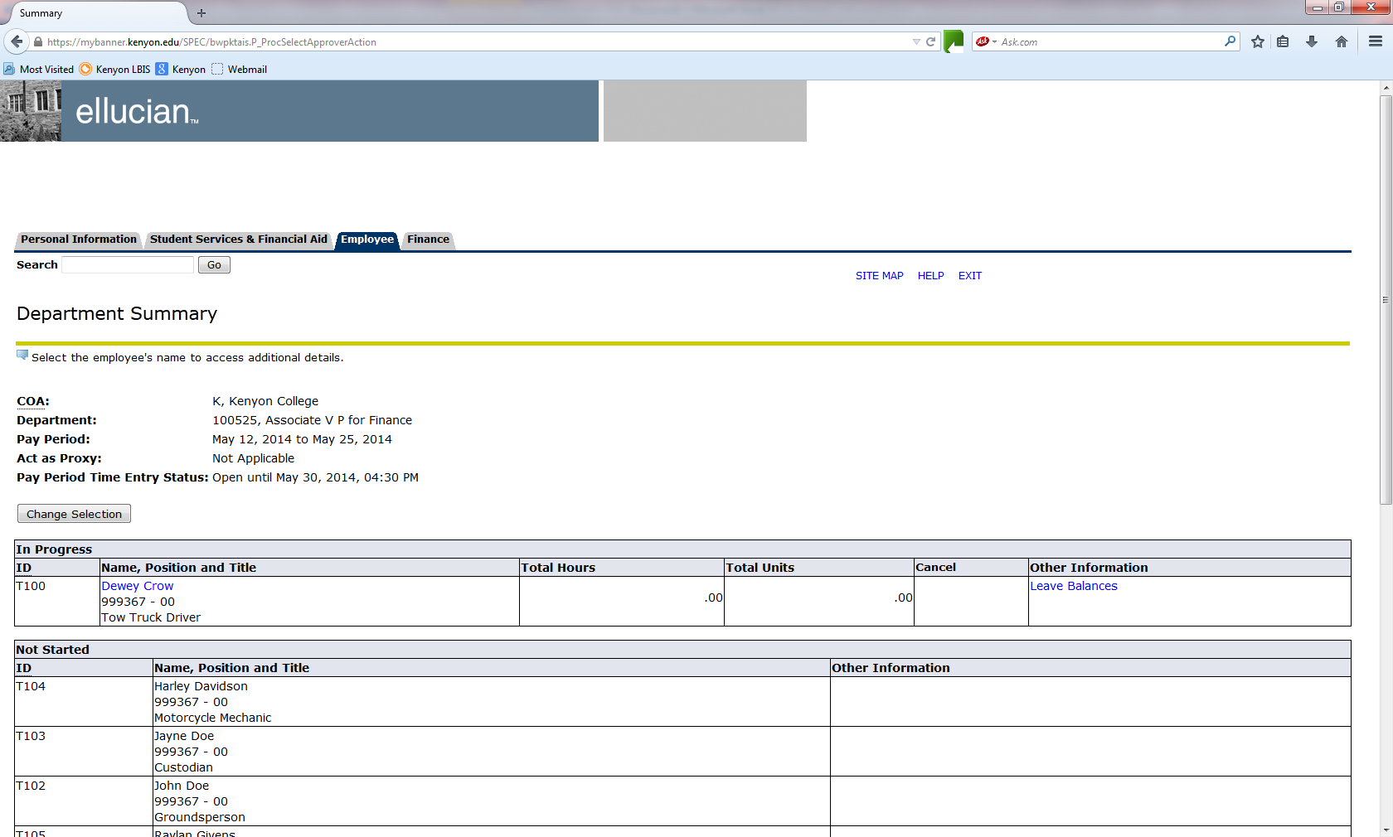

- Employee Detailed Information page

On the Employee Detailed Information page, the approver can do the following:

Approve: Approves the time.

Delete: Pressing this button will irretrievably delete the employee’s timesheet. If you accidentally press this button, a box will pop up asking you if you are sure you want to delete the transaction.

Add Comment: The approver can add a comment to the record. This comment can be viewed by you, the employee and payroll.

Change Record: If necessary, the approver can change the time that has been entered by the employee, before approving it. You must notify the employee if you do this!

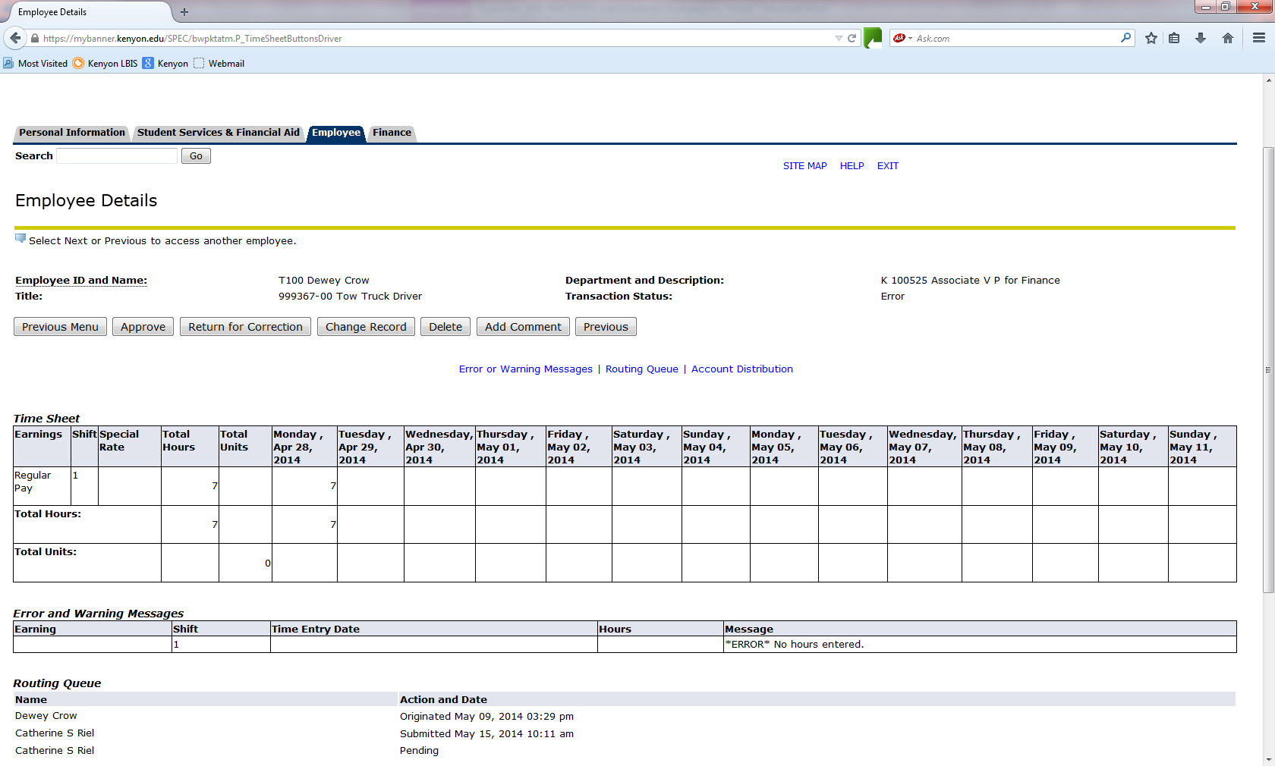

Before exiting, be sure to verify that the status of the employees whom you approved has been changed from Pending to Approved.

- Printing

Past timesheets will remain visible for reviewing purposes. If you also want to keep a printed copy for your records, you may make a screen print from the Employee Detailed Information.

- Ending your session

Log off of your web session, especially if using a public machine, by clicking the EXIT link at the top right hand corner of the web page. Close out of the web browser.

- Assigning a Proxy

Approvers must be set up in the system by payroll personnel. However, approvers are responsible for setting up their own proxies within Banner Web Time Entry. Each supervisor must have one or more proxies who can approve time sheets in his/her absence. A proxy cannot be a staff or student employee. The proxy must be able to verify that the employee has worked the hours submitted. All approvers are encouraged to set up two proxies if possible.
You are responsible for notifying your proxy when they will need to approve your time sheets.

- From the Employee Services menu, choose Time Sheet.

- Click on the link in the center at the bottom of the page called Proxy Set Up.

- From the drop down menu, choose the name of the person who will be your proxy. If you want to designate a new proxy who is not on the pull-down menu, notify payroll.

- Click the Add check box.

- Click Save.
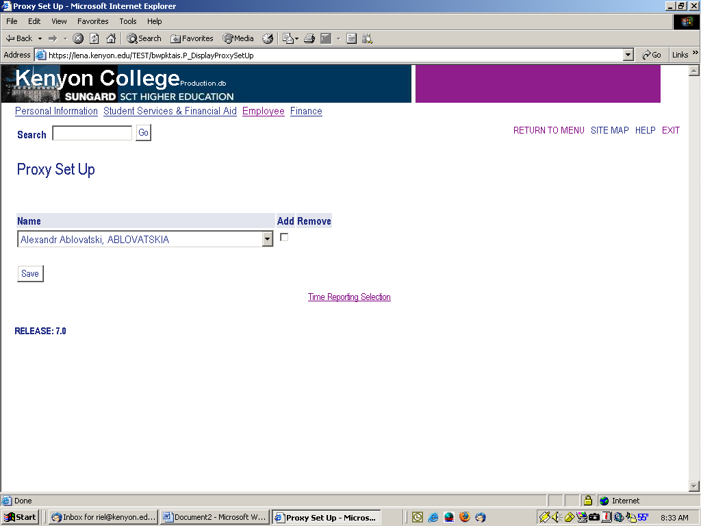

When you have completed adding your proxy, click on the “Time Reporting Section” option at the bottom of your screen.

If a time sheet needs corrected, please read on.

There are two ways to correct a time sheet.

1. In the Summary Screen, click on “RETURN FOR CORRECTION” to send the timesheet back to the student for them to correct and re-submit to you. Be sure to do this before the employee’s submission cut-off date so they have time to correct and re-submit it.

2. You may correct a time sheet by clicking “Change Time Record” at the summary screen. Make the correction and save the record. Click “Previous Menu” then click on “Comments”. Always enter a comment explaining the correction to your employee. Click “Save” to save the comment. Click “Previous Menu” twice and you will be back at the summary screen.

IMPORTANT: Employees are NOT automatically notified that their time sheet was returned to them for correction. It is important that you contact them to allow enough time for them to make corrections and re-submit.

TO SUBMIT A TIME SHEET for an employee who failed to submit before the cut-off date:

If the cut-off date has expired for an employee to submit their time sheet and you would like to submit it for them, follow these simple steps.

1. Go to the Department Summary screen. If the time sheet is under the “In Progress” status, click on the employee’s name. This will bring you to the Employee Detail screen. At the left side of the screen below the employee’s name and title, click on the “Submit” button. This will submit the time sheet to you for approval. At this time you may approve the time sheet as usual.

IMPORTANT NOTE: Please notify Human Resources at 427-5173 as soon as possible if any employee terminates employment so we can remove their position from the online system.

